Scenario 1:
Weak: "Test the search feature."

What's missing: No product type (e-commerce, hospital),
no filter/sort behavior, no empty/invalid input scenarios, no performance angle.

Exact Prompt used:
Role: Senior QA Engineer
Task: Generate detailed test cases for the search functionality of an e-commerce application.
Context: Users can search products by keyword. The application supports category filters, price range filters, brand filters, sorting (relevance, price, newest), auto-suggestions, and pagination.
Requirements:
- Functional test scenarios
- Negative test scenarios
- Boundary value test cases
- Filter and sorting validation
- Security test cases (SQLi, XSS)
- Performance test scenarios
- Accessibility test scenarios
- Mobile responsiveness checks
Output Format: Test Case ID | Scenario | Test Steps | Expected Result | Priority

Refer the below doc for the output of test cases from the prompt

ECommerce_Search_Functionality_Complete_Test_Strategy.docx

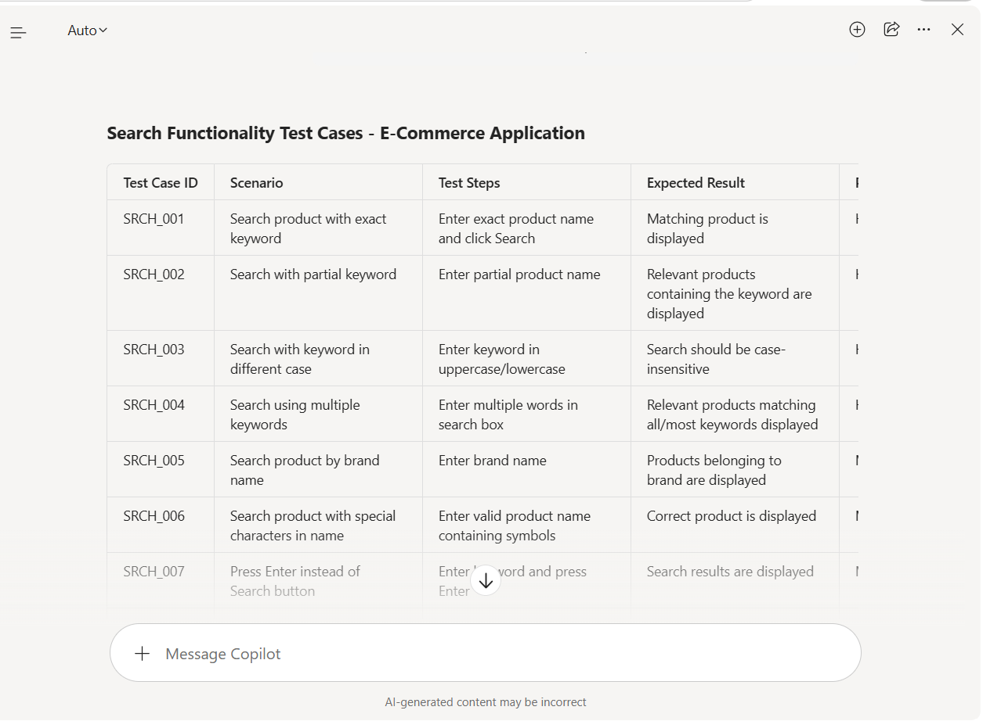

Scenario 3— Shopping Cart

❌ Weak: "Test the cart functionality."

What's missing: No add/remove/update actions,
no price calculation validation, no coupon/discount scenarios, no out-of-stock handling.

Exact Prompt used:

Role: Senior QA Engineer
Task:
Generate detailed test cases for the shopping cart functionality of an e-commerce application.
Context:
Users can add products to the cart, update quantities, remove items, apply coupons, view taxes and shipping charges, and proceed to checkout. The system supports guest users and registered users.
Requirements:
1. Functional cart operations
2. Price calculation validation
3. Coupon and discount scenarios
4. Inventory and stock validation
5. Negative test scenarios
6. Boundary value testing
7. Security validation
8. Performance testing
9. Accessibility testing
10. Mobile responsiveness validation
Output Format:
Test Case ID | Scenario | Test Steps | Expected Result | Priority

Screenshot for reference:

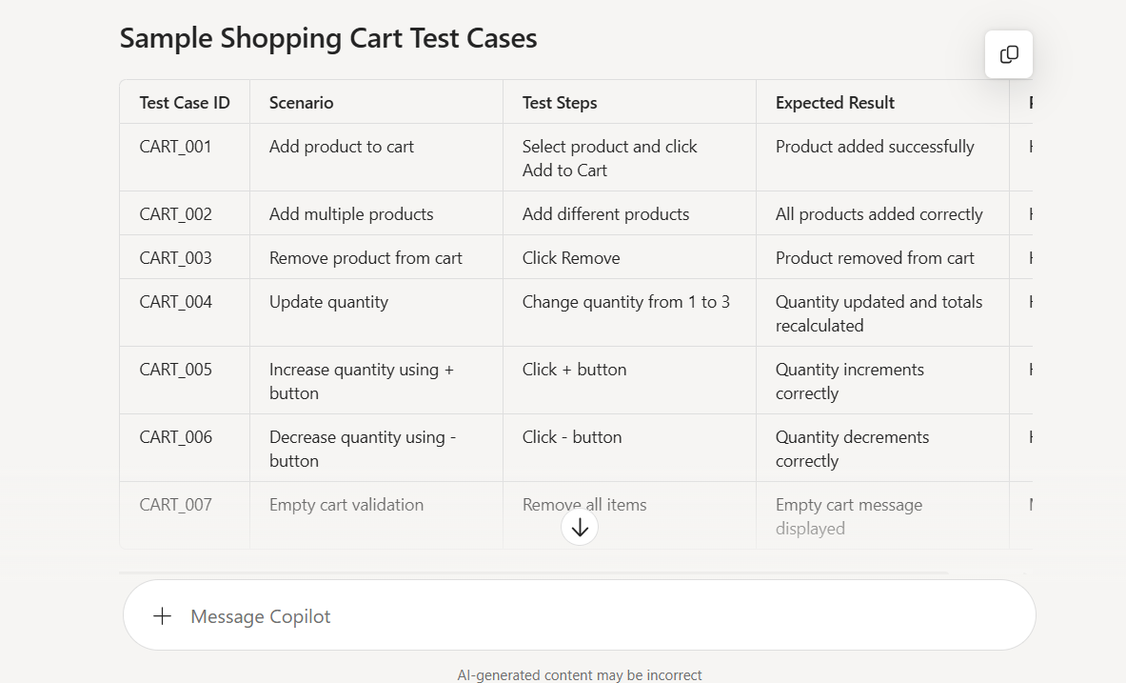
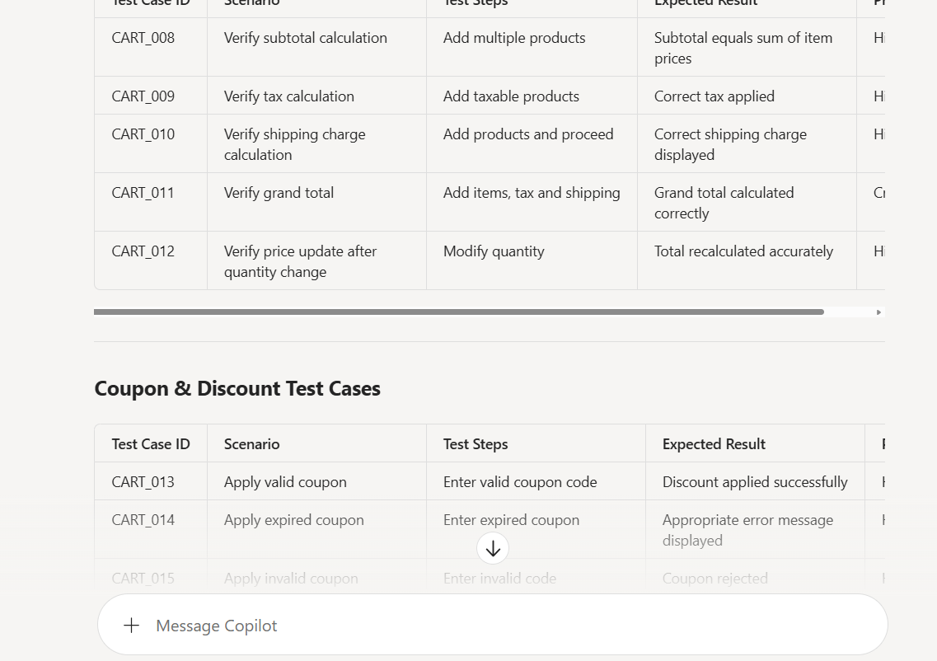

Refer the below doc for the output of test cases from the prompt
Download Shopping_Cart_Test_Cases.docx

Scenario 6 — Mobile App (OTP Login)

❌ Weak: "Test OTP login on mobile."

What's missing: No platform (Android/iOS), no OTP expiry time,
no resend behavior, no network failure scenario, no Appium/device context.

Correct Prompt used:

Context: Test OTP-based login functionality in the mobile application using Appium on Android 14 (Samsung Galaxy S23) and iOS 17 (iPhone 15) devices.
Test Requirements:
- User enters a valid registered mobile number and requests an OTP.
- OTP should be delivered within 30 seconds.
- OTP should remain valid for 5 minutes.
- User should be successfully logged in upon entering the correct OTP.
- Invalid OTP should display an appropriate error message.
- OTP should expire after 5 minutes and require regeneration.
- Resend OTP button should become enabled only after 30 seconds.
- Verify that the previous OTP becomes invalid when a new OTP is generated.
- Test behavior during:
  - No internet connection
  - Slow network (3G simulation)
  - Server timeout/API failure
  - App backgrounding and reopening before OTP submission
- Verify OTP field validations:
  - Empty OTP
  - Partial OTP
  - Alphanumeric characters
  - Copy-paste OTP support
- Verify security aspects:
  - OTP is masked if required by design
  - OTP is not stored in logs
  - Rate limiting after multiple failed attempts
- Validate behavior across:
  - Android and iOS devices
  - Different screen sizes
  - Device orientation changes
Expected Deliverables:
- Functional test scenarios
- Negative test cases
- Edge cases
- Appium automation scenarios
- API validation points for OTP generation and verification services
Screenshot for reference:

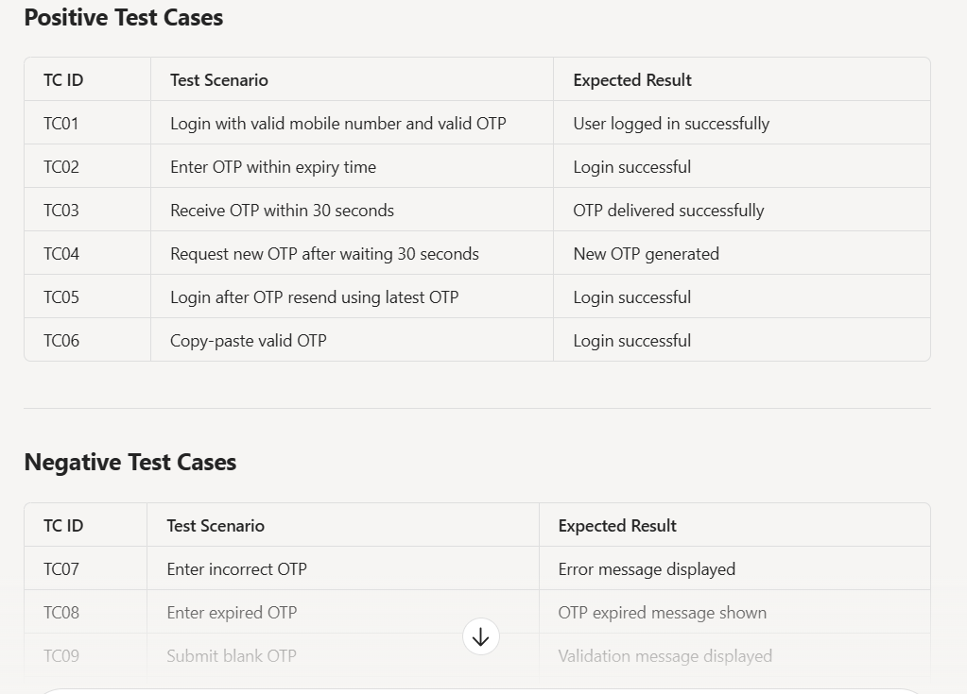
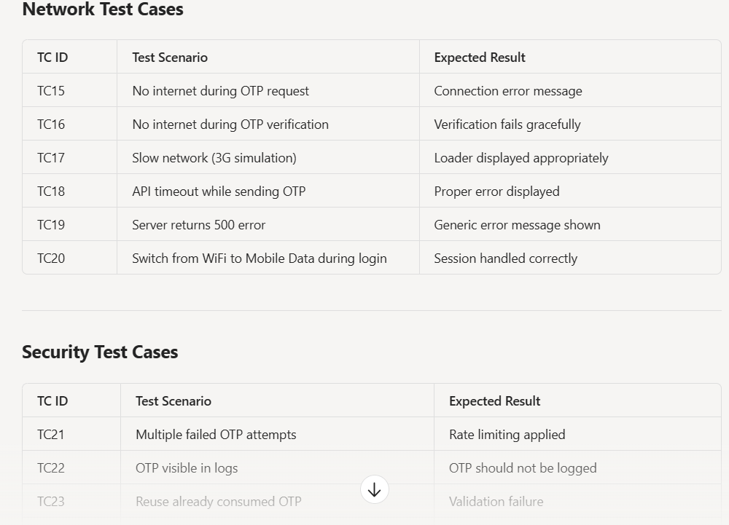

Refer the below doc for the output of test cases from the prompt

Mobile_OTP_Login_Complete_Test_Strategy.docx

